FINAL EXAMINATION
TIME ALLOWED: 90’
Subject: Linear Algebra.
No books allowed.
1/ Find the matrix , such that 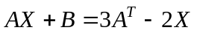, where 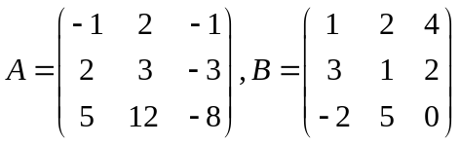.
2/ Compute the determinant of the matrix 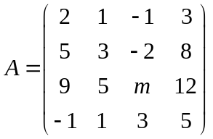.
3/ In 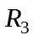 with the inner product ,
given the subspace 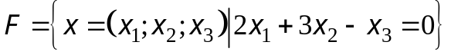.
Find one basis and the dimension of the orthogonal complement 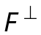 of the subspace F.

4/ Let 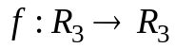 be the linear transformation and 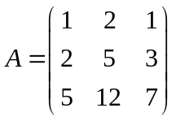 be the matrix of the mapping 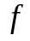 in the basis 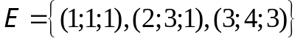.
a/ Compute 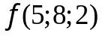.
b/ Find one basis and a dimension of the kernel of the mapping .

5/ Let be the linear transformation and
Assume that .
Find the matrix  of the linear transformation f in the basis
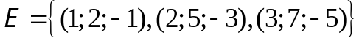.

6/ Determine all real values of such that 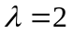 is the eigenvalue of the matrix
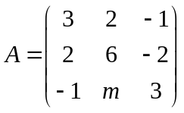.

7/ Make a change of variables that transforms the quadratic form 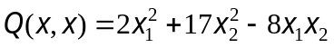
into the canonic form (using the orthogonal diagonalization method).
-----------------------  -----------------------

